Predicting top-priority McDonald’s “Rude” reviews (using NLP)

Start Date: 5-08-2019

Praveen Sequeira

Epic | Sentiment Analysis
Project Status | Requirements
Client | McDonald’s Australia
Project Owner | Praveen Sequeira
Developers/Design | Praveen Sequeira
Stakeholders | Sharon Paz, Director of Operations, McDonald’s Australia
Design complete | 15-08-2019
Code complete | 2-09-2019
Test complete | 12-09-2019
Release date | 19-09-2019

Background
McDonald's Australia receives thousands of customer comments on their website per day, and many of them are negative. Their corporate employees don't have time to read every single comment, but they do want to read a subset of comments that they are most interested in. In particular, the media has recently portrayed their employees as being rude, and so they want to review comments about rude service.
McDonald’s is looking to develop a system that ranks each comment by the likelihood that it is referring to rude service. They will need a "rudeness dashboard" for their corporate employees, so that employees can spend a few minutes each day examining the most relevant recent comments.

Objectives

Objective | Metric
Determine the language of the review | Run the language detector model against all the reviews and then check the language flag against each review
Translate foreign language into English | Run the language translator model against all the reviews and then against each foreign review translated by the model, verify the translation is correct by checking it by using Google Translate
Determine the probability of each review to see if it pertains to a “rude” review | Run the trained classification model against out-of-sample (test) data to check its accuracy and predicted probabilities.

Assumptions
Access to some legitimate training data, ideally to the tune of 25K reviews. More data will translate into more accurate results. This should ideally be organized by McDonald’s Australia. For the training data, each review needs to have been annotated to indicate the violation against the review; for e.g. if the violation is rude, then it needs to be flagged in a separate column against the review. The complaint types are listed below, with the encoding used in the data listed in parentheses:
- Bad Food (BadFood)
- Bad Neighborhood (ScaryMcDs)
- Cost (Cost)
- Dirty Location (Filthy)
- Missing Item (MissingFood)
- Problem with Order (OrderProblem)
- Rude Service (RudeService)
- Slow Service (SlowService)
- None of the above (na)

User Stories & Requirements

Ref # | Name | User Story | Functional Requirements | Notes
1. | Bi-weekly Pie-chart that shows the criticality of the reviews | Sharon Paz, Director of Operations, McDonald’s Australia:  As a Director of operations, I need a dashboard that shows the following details:  - A pie chart that shows the percentage of “rude” reviews in 3 slices of priority: < 70, 70-85 and > 85. The > 85% slice should be shown in Red, to indicate that these are the top-priority rude reviews that need to be delegated to my staff for further analysis and action. This will help me stay on top of how our remedial actions are tracking against the issues that we’re dealing with. | A beautiful pie-chart that shows the breakdown of the severity of the reviews.
2. | Bi-weekly Severity report | Ed Machado, Operations Manager, McDonald’s Australia:  As an operations manager, in addition to the pie chart (as listed in the user story for Director of operations), I also want the to-be-prioritized review in the descending order of severity. This will help me to ensure that my staff is optimizing their time in analyzing and interacting with other departments such as Human Resources to stop any rude culture that is running our brand reputation and business. | A report that shows the review and severity (listed in order of decreasing priority)

Open Questions

Question | Answer | Date Answered
At what time intervals should we schedule training updates to the model? | McDonald’s has confirmed that we schedule this on Sunday at 12 am on a bi-weekly basis. | 16/09/2019

List all the things out of scope

Ref # | Functional Requirements
1. | A report of all underperforming stores that have high levels of negative sentiments. This will be used to analyze the reasons for the underperformance.
2. | A generic report of all the top-priority reviews for all violations other than “rudeness” which is the goal for the current project.

Risks

Risk | Likelihood | Impact | Mitigation
Quality / Quantity of training data | Medium | High | At least 23K reviews will be needed in the training data. These will need to be annotated by a linguistic expert.
Model accuracy levels on unseen (live) data | Medium | Medium | Usage of slang language may influence the accuracy of the predictions to some extent during the first deployment. A bi-weekly schedule to subsequent train the model on new data, will continually improve the accuracy on the model.

Design

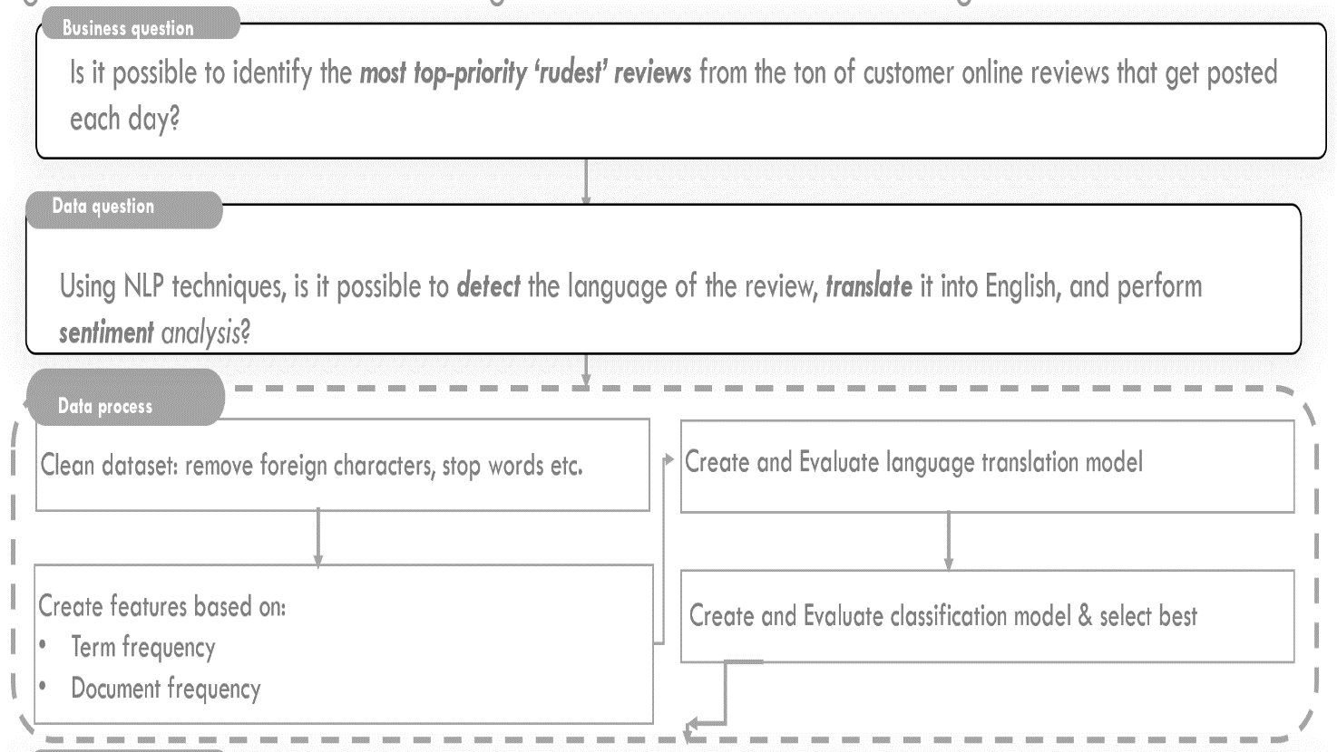

Tasks

Ref # | Person | Task | Completion Date
1. | Praveen Sequeira | Requirement gathering and Analysis | 10-08-2019
2. | Praveen Sequeira | Design | 15-08-2019
3. | Praveen Sequeira | Coding – Phase 1: Language Model | 25-08-2019
4. | Praveen Sequeira | Testing – Phase 1: Language Model | 27-08-2019
5. | Praveen Sequeira | Coding – Phase 2: Classification Model | 02-09-12018
6. | Praveen Sequeira | Testing – Phase 2: Classification Model | 12-09-12018
7. | Praveen Sequeira | Release / Deployment | 19-09-12018

Results and Conclusions

Ref # | Context | Notes
1. | Were the objectives achieved? | Yes, McDonald’s Australia have confirmed that all the objectives that were set out at the start of the project have been achieved and the project completed well ahead of time.
2. | Conclusions / Insights | The only hurdle that we had in this project was the format of the data and the sources from where the data was sourced by the company that annotated the reviews. As a result, some time was lost in making data available from a variety of sources and requesting for the key indicators that were needed for the data in this project. This has now been streamlined, so any subsequent project can benefit from the time invested in getting the data sorted.
3. | Next steps | Following the success of this project, we can liaise with McDonald’s Australia to undertake the other projects that they were interested in. Please refer to the section: List all the things out of scope.
4. | Recommendations | The best project to first pick up would be the project mentioned in Ref # 2 (A generic report of all the top-priority reviews for all violations other than “rudeness” which is the goal for the current project.)  This is because of the similarity of this project with the project mentioned in this document. We can leverage a lot of work from this project, and achieve similar results with less effort.  Project mentioned in Ref # 1 can be taken up next.

